# PNHS WEB-BASED EXAMINATION AND PERFORMANCE MANAGEMENT SYSTEM

A project study presented to the faculty of

South East Asian Institute of Technology

College of Information and Communication Technology

In partial Fulfillment

of the requirement for the subject

IT 228: System Analysis and Design

**By:**

**Ricky Mercado**

**Amir Hedji N. Ramac**

**Arvie Jyro Felisilda**

**Christian Vincent N. Mina**

**Rhea May Carriedo**

APRIL 2025

**Approval Sheet**

This System Analysis and Design Project entitled **PNHS Web-based Examination and Performance Management System**, prepared and submitted by **Ricky B. Mercado, Amir Hedji N. Ramac, Christian Vincent N. Mina**, **Arvie Jyro Felisilda, Rhea May Carriedo** in partial fulfillment of the requirement for the subject IT228: System Analysis and Design, is hereby accepted.

|  |
| --- |
| **Hernan Jr. E. Trillano, MIT** |

|  |  |  |  |  |  |  |
| --- | --- | --- | --- | --- | --- | --- |
| Adviser   |  |  |  | | --- | --- | --- | | **Ma. Anjelly E. Fusingan, MIT** |  | **Ile Nathaniel N. Flores, MIT** | | Panel Reviewer |  | Panel Reviewer |   Accepted and approved for the degree of  **Bachelor of Science in Information Technology** Abstract Polomolok National High School faced several challenges in its examination processes, including manual examination checking, exceeding the time limit, delays in student data processing, and performance. To address this issue, a Web-based Examination and Performance Management System was developed. The system integrates key features such as anti-cheating measures, time limit per exam part, automated examination checking, student data analytics, and exam score report. Advanced functionalities, such as an examination portal, tab-exit monitoring, and performance analytics, were integrated to enhance functionality efficiency. The development followed the Agile Methodology, allowing for iterative improvements based on testing and user feedback.  To evaluate usability and effectiveness, the System Usability Scale (SUS) was provided to teachers and students at Polomolok National High School who actively used the system. Respondents validated the system as functional, efficient, and user-friendly. It successfully addressed the identified problems and received positive feedback, especially the automated examination checking. Overall, the Web-based Examination and Performance Management System demonstrates a successful and scalable effective solution for academic examination processes.  ***Keywords:*** Web-based Examination, Performance Management, Agile Methodology, Polomolok National High School Acknowledgments The researchers would like to express their heartfelt feelings of gratitude to the following, who were willing to share their knowledge, time, and efforts for this research.  First and foremost, we extend our deepest thanks to **Hernan Jr. E. Trillano, MIT**, our project adviser in the subject IT 228: System Analysis and Design, for his unwavering support, valuable recommendations, guidance, consideration, and patience in guiding us through the difficulties of this research.  We are also grateful to our panel reviewers, **Ile Nathaniel Flores, MIT**, **Cedie B. Gabriel, MIT,** and **Ma. Anjelly E. Fusingan, MIT**, for their critical evaluations, constructive feedback, and insightful suggestions, all of which greatly contributed to the improvement of this project.  We also would like to express our heartfelt appreciation to our **family** and **friends** for their continuous encouragement and understanding. Their unwavering support serves as a source of strength and motivation throughout this journey.  Above all, the researchers extend their utmost gratitude to the **Almighty God** for providing strength, wisdom, and guidance from the beginning to the successful completion of this research. His divine provision made all things possible TABLE OF CONTENTS PNHS WEB-BASED EXAMINATION AND PERFORMANCE MANAGEMENT SYSTEM i  **Approval Sheet** ii  Abstract ii  Acknowledgments iii  TABLE OF CONTENTS iv  LIST OF TABLES vi  LIST OF FIGURES vii  CHAPTER I 1  Rationale of the Study 1  Objectives of the Study 3  General Objectives 3  Specific Objectives 3  Scope and Limitations of the Study 4  Scope of the Study 4  Limitations of the Study 5  Significance of the Study 6  FLOW OF THE STUDY 7  Definition of Terms 8  CHAPTER II 9  Foreign Literature 9  Local Literature 11  Foreign Studies 14  Local Studies 16  CHAPTER III 20  RESEARCH METHODOLOGY AND DESIGN 20  Environment 20  Software Methodology 20  Business Model Canvas 24  Gantt Chart 25  Functional Decomposition Diagram 26  Use Case Design Phase 27  Use Case Matrix 28  Storyboard 29  Database Design 37  Entity Relationship Diagram 38  Data Dictionary 39  Network Design 43  Network Topology 43  Development/Construction/Build Phase 44  Technological Stack 44  Software Specification 44  Hardware Specification 44  Program Specification 45  List of Modules 45  CHAPTER IV 46  RESULTS AND DISCUSSION 46  **Development and Testing** 46  **System Usability Scale** 47  **Evaluation Result** 48  **Definition of the Prototype** 54  Conclusions 55  Recommendations 55  References 57  CURRICULUM VITAE 58  APPENDICES 64  (Transmittal Letter) 65  (Project Proposal) 68  (Questionnaire) 73  (Map of Research Environment) 75 LIST OF TABLES **Table Title Page**  1 Flow of the Study 7  2 Use Case Diagram 27  3 Use Case Matrix 28  4 Data Dictionary(users table) 39  5 Data Dictionary(subjects table) 39  6 Data Dictionary(enrollments table) 40  7 Data Dictionary(exams table) 40  8 Data Dictionary(questions table) 40  9 Data Dictionary(choices table) 41  10 Data Dictionary(exam_part_timer tables) 41  11 Data Dictionary(students_answers table) 41  12 Data Dictionary(exam_submissions table) 42  13 Data Dictionary(cheating_logs table) 42 LIST OF FIGURES **Table Title Page**  1 Software Engineering Methodology 20  2 Business Model Canvas 24  3 Gantt Chart 25  4 Functional Decomposition Diagram 26  5 Database Design 37  6 Entity Relationship Diagram (ERD) 38  7 Network Topology 43  8 Technological Stack 44 |
|  |

# 

# CHAPTER I

**INTRODUCTION**

## Rationale of the Study

Web-based examination and performance management is an online platform designed to conducting exams of the students and managing the students’ performance and it provides secure and efficient way for students to take examinations. The web-based examinations and performance management system aims to improve conducting examinations management in terms of accuracy, time consuming, efficiency, and general management and to reduce expenses of the school like exams paper-based and manual grading and it can also help track students’ performance over time. The system makes it easier for teachers, students, to access real-time updates on academic progress. This system can withstand various challenges that hinder the adoption of e-learning technologies in developing countries. This is important because it will reduce the time and cost involved in conducting large scale examinations by tertiary institutions without the need to upgrade existing infrastructures (Eko et al., 2022). Furthermore Performance management among students this assessment is normally done by grading students’ performance in various assessment modules set by the institution such as beginning of term examinations, mid-term examinations, end of term examinations and various tests done along the term period (Moses et al., 2020).This research gap outlines the need combination of a web-based examinations system with performance management to further monitor the performance along with the examinations of the students.

Polomolok National High School (PNHS) started its operations on August 21, 1957. The school has an approximate population of 15,000 students for the school year 2024 – 2025. The school has a Junior High School and Senior High School, and there are a guidance office and principal office, and buildings for the Junior High School and Senior High School. Until now, their exams and grading sheets are still paper-based, and some teachers handle the examinations. During examinations, some teachers distribute the examinations by each subject teacher, and there is a proctor watching over the students while they are taking the examinations.After their examinations, their teacher even asked the students to check their exams because there were so many students, and so that the teacher could record their exam scores, and sometimes the teacher would check their examinations.

The PNHS School Examinations face challenges due to the traditional paper-based method, such as: (1) Paper-based exams are prone to cheating such as answer sheet swapping, causing unfair assessment; (2) Teachers tend to monitor exam time manually, somehow it exceeds to a time limit; (3) Manual checking is time- consuming due to a large number of student and double checking answers leading delayed score results; (4) Teachers rely on manually recorded scores for student performance reports, making it difficult to identify areas of improvement and provide academic reports; and, (5) Manually record reports is time-consuming due to manually collect each exam scores leading to delayed scores reports.

The PNHS Web-based Examination and Performance Management System aims to manage these limitations. The examination is more efficient and enhances student performance at Polomolok National High School. Storing all processes in a database will simplify teacher record-keeping, such as examinations, answers, scores, and report retrieval. This will enable the school to provide more efficient, effective, and secure examinations for students. Implementing this system is not just a technological upgrade but a dedication to better student examination and performance.

## Objectives of the Study

### General Objectives

The researchers aim to study and develop a Web-Based Examinations and Performance Management System (WEB-BASED EPMS) for Polomolok National High School. located at Octavio Village, Cannery Site, Polomolok, South Cotabato 9504.

### Specific Objectives

* To implement anti-cheating measures such as random-order questions and tab-monitoring to prevent cheating.
* To prevent exceeding the time limit for each exam, ensuring a fair amount of time each student to answer.
* To improve checking exam accuracy by automating the checking examination for multiple-choice, true or false, and fill-in-the-blanks, to reduce manual workload for teachers.
* To provide data analytics on student performance by generating reports to help teachers identify areas of improvement for each student.
* To provide exam scores for student examinations by generating reports to help teachers organize and calculate each student’s examination score.

## Scope and Limitations of the Study

### Scope of the Study

The PNHS Web-based examination and performance management system is capable of the following:

**Anti-Cheating Measure**

These random-order questions will help prevent sharing answers due to the similarities of questions in each exam part. Tab monitoring in the system helps to detect if a student is opening other tabs.

**Exam Time Limit**

This will have an exam time limit. This system has a specific time to be submitted. This enables the student to manage time in answering the question and helps the teacher to prevent exceeding to time limit.

**Automated Examination Checking**

This automatically checks the exam that the student takes. This will help the teacher save time and effort when checking the answer.

**Student Data Analytics**

It provides generated data analytics for each student to track their strength and weaknesses in exams. This will help to save time for teachers in manually recording each exam score.

**Exam Score Report**

It provides generated exam score analytics of each exam score to track their performance. This will help to save effort and time for teachers in manually calculating each exam score per examination.

### Limitations of the Study

The study is only intended for the PNHS School. This research project focuses only on anti-cheating measures that randomize questions, prevent opening other tabs, balance examination time across each exam part, and automatically check students’ exams in various types of exams including multiple choice, true or false, and fill-in-the-blanks and students’ performance analytics by each subject; and score reports each exam. This system will not include functionalities for making general checking of a student per subject, and will not support checking an essay-type question. Questions will not be automatically made it will depend on the questions that teachers entered. Technical issues or power outages could disrupt system access.

## Significance of the Study

This study aims to develop a Web-Based Examination and Performance Management System. The system has the potential to significantly impact the school, teachers, and students, leading to improved efficiency and fairness in the examination process. This system aims to benefit the following:

**PNHS**

The school will eliminate the need for paper-based exams, saving time in distribution and collection, reducing manual work, and lowering cost.

**Teachers**

The teachers can create, schedule, and administer exams online without the hassle of printing and distributing papers.

**Students**

The system allows students to take exams anytime, receive instant feedback, track their progress, and get reminders for pending assessments.

**Researchers**

Can use their skills and knowledge in research. It is an opportunity for the researchers to put into practice what they have learned as Information Technology students.

**Future Researchers**

This system would be a great help for future researchers. The documentation and system will serve as their literature or prior art, and the system can be upgraded based on the new requirements.

## FLOW OF THE STUDY

**INPUT PROCESS OUTPUT**

* Set-up activity alerts
* Set-up exam timer
* Check student exam
* Create analytical reports
* Create exam score report
* Monitoring activity alert
* Monitoring exam
* Automating examination checking
* Generating analytical reports
* Generating exam score report
* Display activity alert
* Display time limit
* Display exam scores

* Display/Print analytical and performance reports
* Display exam score report

*Figure 1.1: Flow of the Study of PNHS WEB-BASED EPMS:* *PNHS WEB-BASED EXAMINATION AND PERFORMANCE MANAGEMENT SYSTEM*

## Definition of Terms

**Academic Reports –** Performance summaries generated based on student exam results.

**Assessment –** a comprehensive evaluation of the students’ records.

**Automation –** reduces the tasks the teacher’s staff have to do manually.

**Efficiency –** Reflects the system’s goal of improving examination management.

**Guidance office –** acting as a resource for students, and teachers to address challenges and promote well-being.

**Implementation –** process of putting a decision or plan.

**Manual Checking –** The traditional process of grading exams by hand which is time-consuming and prone to errors.

**Monitoring –** keeping track and checking the students while answering.

**Performance Management System –** An instrument to monitor, evaluate, and oversee student academic progress.

**Real-Time Updates –** Instant access to students’ academic progress and examination results.

**Security –** Ensures safe and reliable assessment procedures, minimizing cheating risks.

**Web-based system –** Emphasizes the transition from traditional to digital examination methods.

# CHAPTER II

**REVIEW OF RELATED LITERATURE AND STUDIES**

To address many concepts, ideas, and understandings involving both local and foreign literature of the studies, a review of connected literature and studies is established. The information from the past to the present is analyzed and provided in this study, which aids the researcher in creating project proposals. The various studies and publications related to the clinic management system.

**Review of Related Literature**

## Foreign Literature

**A systematic review of online examinations: A pedagogical innovation for scalable authentication and integrity**

[*https://pmc.ncbi.nlm.nih.gov/articles/PMC7508171/*](https://pmc.ncbi.nlm.nih.gov/articles/PMC7508171/)

Digitization and automation have improved efficiency in many industries, including higher education. While online learning, e-learning, and digital assessments are common, the use of online proctored exams is still rare in many countries. This paper provides a background on online exams and presents the findings from a systematic review of the topic to explore both challenges and opportunities. It discusses results from 36 studies, focusing on nine key areas: student views, performance, anxiety, cheating, staff views, security, interface design, and technology issues. Although the research on online exams is growing, there is still little discussion about teaching methods and governance. (Henderson & Crawford , 2020).

**A Systematic Review of Online Exams Solutions in E-Learning: Techniques, Tools, and Global Adoption**

[**https://www.researchgate.net/publication/349458625_A_Systematic_Review_of_Online_Exams_Solutions_in_E-Learning_Techniques_Tools_and_Global_Adoption**](https://www.researchgate.net/publication/349458625_A_Systematic_Review_of_Online_Exams_Solutions_in_E-Learning_Techniques_Tools_and_Global_Adoption)

E-learning in higher education has grown very quickly over the last decade because of its important benefits during emergencies like natural disasters (such as the COVID-19 pandemic) and war. Conducting online exams in a reliable, fair, and smooth way is very important in E-learning. Since online exams are done without students and teachers being together in the same place, problems like cheating and security issues can happen. To solve these problems, researchers have suggested many tools and techniques. However, there are very few studies that fully review the latest developments in online examinations. To address this, Muzaffar et al. (2021) carried out a Systematic Literature Review (SLR), selecting and studying 53 research papers published between January 2016 and July 2020. They identified five major features often focused on in online exams and explored different ways to develop online exam systems. They also highlighted 16 important techniques and algorithms, 11 datasets, 21 newly proposed online exam tools, and 25 existing tools used in the reviewed studies. The study further analyzed the contributions of different countries to online exam research and identified key factors that influence the global use of online exams, comparing them to the major features needed for a successful system. Their findings help guide researchers and practitioners in choosing the right features, development methods, tools, and techniques based on the needs and resources of different countries. (Muzaffar et al,2021)

**Emerging trends of online assessment systems in the emergency remote teaching period**

[**http://link.springer.com/article/10.1186/s40561-022-00199-**](http://link.springer.com/article/10.1186/s40561-022-00199-)**6**

The COVID-19 pandemic forced many schools and universities around the world to quickly switch to distance learning, a process called "Emergency Remote Teaching." This sudden change created many problems, especially in how students were assessed. To handle this, many institutions started using online assessment systems, and researchers began studying these systems. This research focuses on the main features of online assessment systems during the Emergency Remote Teaching period. It aimed to find out which platforms the systems support, what security features they offer, and what common features they share. By analyzing academic papers published in 2020, the study identified the most popular online assessment tools. The goal was to discover trends in these systems' features to help educators, decision-makers, researchers, and developers choose or create better online assessment tools for future use.(Touz et al,2022)

## Local Literature

**Online Examination System**

**https://link.springer.com/chapter/10.1007/978-981-16-4016-2_67**

Before the COVID-19 pandemic, educational institutions primarily relied on traditional methods for conducting examinations, which were often slow and inefficient. The pandemic led to widespread school closures and lockdowns, prompting governments worldwide to shift to remote teaching and learning. This transition raised questions about how online examinations could be effectively implemented. An online examination system offers a digital platform that allows students to take exams from anywhere, at any time, streamlining the assessment process. However, as online exams become more common, ensuring the integrity and security of both the exams and student data has become a significant concern. Experts are now seeking software solutions equipped with robust security features to confidently assess student performance and provide timely feedback, addressing challenges both during and beyond the pandemic. (Tripathi et al,2021)

**OPEES: Online Proctored Entrance Examination System with Degree Program Recommender for Colleges and Universities**

[*https://ieeexplore.ieee.org/abstract/document/10109595*](https://ieeexplore.ieee.org/abstract/document/10109595)

Since many schools cannot offer an online admissions exam, they rely on grades and interviews to admit and qualify students for degree programs. However, academic standards differ between schools, and grades may not be enough to assess students' capacity. Thus, this study aims to develop an Online Proctored Entrance Examination System (OPEES) with Degree Program Recommender for colleges and universities to help institutions administer onsite or online entrance tests and generate course suggestions using a rule-based algorithm. The study employed the scrum methodology in software development. OPEES allows applicants to submit applications online, and institutions can manage user accounts, tailor exams and degree programs’ criteria, manage exam dates, and assign proctors. Online proctoring using Jitsi, an opensource multiplatform voice, video, and instant messaging tool with end-to-end encryption, ensures exam integrity. The system addresses the challenge of conducting entrance exams in a standardized and secure manner (Bulauitan et al., 2022).

**A Web-Based Mechanical Engineering Pre-Board Examination System with Progress Report for JCSF Engineering Review Center**

[*https://www.ejournals.ph/article.php?id=19655&fbclid=IwY2xjawJg8VRleHRuA2FlbQIxMAABHtN-elhALzqQv083pVyTmwyRrA4pMdKrHHs3r1FhHxiuLMKfmUjph7unSOUt_aem_E5jppIHfiVJUjQ4CAFEfiQ*](https://www.ejournals.ph/article.php?id=19655&fbclid=IwY2xjawJg8VRleHRuA2FlbQIxMAABHtN-elhALzqQv083pVyTmwyRrA4pMdKrHHs3r1FhHxiuLMKfmUjph7unSOUt_aem_E5jppIHfiVJUjQ4CAFEfiQ)

The researchers were asked to develop a web-based system that will determine the preparedness of the examinees in taking the board examination, identify their weak areas corresponding to their pre-board assessment exam, and address the manual process in checking and creating an examination. Based on the system evaluation, the results showed that the system achieved the said objectives. Specifically, the examinee was satisfied with the help of the system in answering test, downloading handouts, and in determining his/her weak areas; the system provided reports based on the previous pre-assessment results; it helped in checking the exams automatically and in providing test results immediately; it helped in uploading handouts for the examinees to download; it was reliable, usable, efficient, maintainable, and portable. The researchers concluded that the proposed system for JCSF Engineering Review Center will make the assessment procedures, giving handouts, conducting and checking assessment tests, and making reports be done faster and with much ease (Diaz et al., 2020).

**Review of Related Studies**

## Foreign Studies

**WEB-BASED ONLINE EXAM INFORMATION SYSTEM TO IMPROVE THE QUALITY OF LEARNING EVALUATION FOR STUDENTS**

<https://ije3.esc-id.org/index.php/home/article/view/114>

Digitalization now means using systems that are based on digital technology. The online examination system created in this research is designed for elementary schools, especially for Integrated Islamic Boarding Schools (SDIT). The goal of this system is to help students take exams more easily and quickly, and to allow them to view their scores and evaluations afterward. The process of creating this system started with studying what the system needs, followed by designing the system through business processes, functional requirement (FR) tables, use case diagrams and descriptions, and class diagrams. After that, the database was designed using ERD, table relationships, and table structures. The user interface and system testing were also designed using the BlackBox method. The final result is a web-based online exam system that allows students to take exams online and see their scores after completing them (Wulandari, 2022).

**Implementation of Departmental and Periodical Examination Analyzer System**

[**https://arxiv.org/abs/2103.05252**](https://arxiv.org/abs/2103.05252)

Administering examinations both in public and private academic institutions can be tedious and unmanageable. The multiplicity of problems affecting the conduct of departmental and periodical examination can be greatly reduced by automating the examination process. The purpose of this action research is to provide an alternative technical solution in administering test through the use of Examination System. This software application can facilitate a plenitude of examinees for different subjects that implements a random questioning technique and can generate item analysis and test results. The Departmental and Periodical Examination System was developed using Visual Basic language. The software modules were tested using the functional testing method. Using the criteria and metrics of ISO 9126 software quality model, the system was evaluated by a group of students, teachers, school administrators and information technology professionals and has received an overall weighted mean of 4.56585 with an excellent descriptive rating. Therefore, the performance of the application software provides solution that can surmount the gargantuan problems of test administration and post-examination issues and performs all the operations specified in the objectives. (Julius G. Garcia & Connie C. Aunario, 2021)

**Exams Item Analysis, Online Examination, and Education Evaluation System Via Internet**

[*https://ieeexplore.ieee.org/document/10153296*](https://ieeexplore.ieee.org/document/10153296)

The goal of this study is to create an online exam item bank management system. This system analyzes the reliability of exams using K-R 20 and K-R 21 formulas. It also calculates the difficulty and discrimination power of the exam questions by analyzing the choices and comparing the top and bottom groups. The system allows for creating exam sets either randomly or based on difficulty levels. Students can take exams online, and results are announced immediately. The grading system helps evaluate students' learning achievements. The system’s accuracy was tested and matched the results of manual calculations. It was also tested with a sample group, and satisfaction levels were measured through questionnaires. Teachers and students were the most satisfied, while administrators also showed a high level of satisfaction. The exam management system operates as a web application with a security system to support learning activities. (Chaidee et al., 2023).

## Local Studies

**Development of Dynamic Local Area Network (LAN) Based Mock Board Examination System**

<https://arxiv.org/abs/2012.01139>

Purpose-Mock board exam is necessary to identify if the students are ready to take the board exam. However, preparing for the examination is not easy. It takes too much time to release the result, given that the College has limited personnel. Thus, the proponents developed the Dynamic Local Area Network (LAN) Based Mock Board Examination System that makes the preparation and checking easy.

Method-The proponents followed the iterative waterfall model to develop the system efficiently. Some criteria of ISO 25010 were adopted in the evaluation instrument. Simultaneously, evaluators are composed of program chairperson, College of Computer Studies (CCS) faculty, board program students, and alumni.

Results-The result of 4.91 in Functional Suitability, 4.87 in Performance Efficiency, 4.91 in Usability, 4.90 in Security, and 4.92 in Maintainability shows that the system is fully functional and is usable by any board program.

Conclusion The computer-based examination, implemented through LAN, can simplify administering personnel of MinSCAT mock board examination. The development of the "Dynamic LAN Based Mock Board Examination System" is a great help to the MinSCAT and their board program graduates if it is implemented.

Recommendations-The system has hidden weaknesses that were only identified in actual operation. Thus, further testing is needed, like beta testing, to identify and correct it for better performance. After beta-testing, the system can be improved through iteration of the Waterfall Model phases.

Research Implications-The developed system can improve the mock board examination process and ease preparing this significant examination. Moreover, it immediately provides a result that helps the examinees to identify their weaknesses and do a further review to master it. (Charis Ann M. Sancho & Uriel M. Melendres, 2020)

**Digital Student Examination System of Cebu Normal University -**

**Balamban Campus in the New Normal: Analysis and Implementation**

[*https://www.researchgate.net/profile/Deofel-Balijon/publication/366292740_Digital_Student_Examination_System_of_Cebu_Normal_University_-_Balamban_Campus_in_the_New_Normal_Analysis_and_Implementation/links/63cfdb126fe15d6a574476b8/Digital-Student-Examination-System-of-Cebu-Normal-University-Balamban-Campus-in-the-New-Normal-Analysis-and-Implementation.pdf*](https://www.researchgate.net/profile/Deofel-Balijon/publication/366292740_Digital_Student_Examination_System_of_Cebu_Normal_University_-_Balamban_Campus_in_the_New_Normal_Analysis_and_Implementation/links/63cfdb126fe15d6a574476b8/Digital-Student-Examination-System-of-Cebu-Normal-University-Balamban-Campus-in-the-New-Normal-Analysis-and-Implementation.pdf)

This study aimed to improve the exam process at Cebu Normal University – Balamban Campus by implementing a digital student examination system. The system uses computers for authorized users, allowing faculty and instructors to easily monitor exams. Before the exam day, the system lets instructors update questions and answers. To ensure authenticity, students must enter their information on the computer, and they will see a randomized set of questions, preventing them from comparing answers. Since the system is digital, exam results are provided immediately after the exam. The system offers a more efficient and effective way of administering exams compared to traditional methods. It enhances the learning process by using computer-based technology while ensuring proper quality control. This digital system aims to provide faster and more accurate assessments, meeting the needs of modern education and the demands of the 21st century. Faculty and administration are encouraged to become familiar with this system for better exam delivery and evaluation. (Letigio & Balijon,2022).

**TESTTIME: An Online Examination System**

[*https://repository.upou.edu.ph/items/ae4d99a7-d3cd-4ab5-ac75-d4b886356039*](https://repository.upou.edu.ph/items/ae4d99a7-d3cd-4ab5-ac75-d4b886356039)

The UPOU Office of Student Affairs (OSA) Examination Services Program started giving exams through an online non-proctored or online proctored double setup due to the ongoing COVID-19 pandemic (UPOU OSA, 2020). The project, called Test Time, is an online examination system designed to help UPOU conduct exams for students in a more organized way without losing exam integrity. The system includes features for registering users such as students and teachers. If the user is a teacher, the system allows them to add, edit, or delete examinations and grades. If the user is a student, the system lets them browse, read, take, and review exam questions, submit their answers, and send requests for clarifications or rechecking. It also lets a user who is a teacher or faculty member use a proctoring system while the student is taking the exam, using webcam or screen recording to watch the student in real time. The project also includes a review of other online exam systems and available options. Student feedback was collected to evaluate how easy and useful the system is, and suggestions for improvement were also included. (Ramos, 2022).

# CHAPTER III

# RESEARCH METHODOLOGY AND DESIGN

This chapter presents theories associated with obtaining necessary to be used in this study, software methodology, research design, and system development phases, which include the planning, design, development, testing, deployment, and review.

## Environment

The study took place at the Octavio Village, Cannery Site, Polomolok, South Cotabato.

## Software Methodology

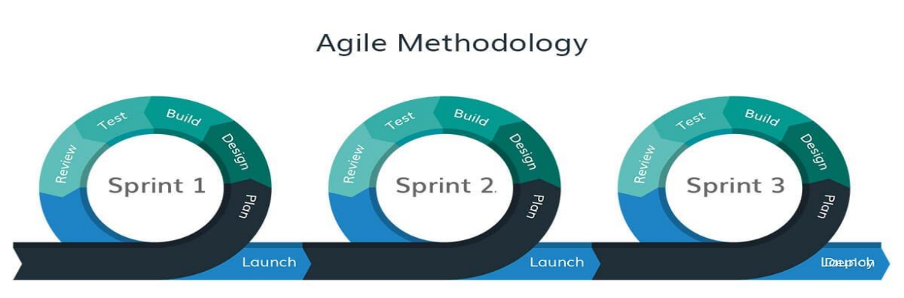The Agile Model Methodology will be used for the software development of PNHS Web-Based Examination and Performance Management System. Agile methodology is a project management framework that breaks projects down into several dynamic phases, commonly known as sprints. The Agile framework is an iterative methodology. After every sprint, teams reflect and look back to see if there was anything that could be improved so they can adjust their strategy for the next sprint (Laoyan, 2025). The model comprises six (6) phases, which include:

*Figure 3.1: Software Model: Agile Model for PNHS WBEPMS that illustrates the System Development Process.*

**System Development Phases**

**Plan**

Developing the PNHS Web-based Examination and Performance Management System using Agile Model Methodology. During this phase, the researchers gather to prioritize user requirements such as Exam Creation Module, Examination Page, Exam Timer, and Cheating Prevention Measure using interviews. Examination within the teachers and students of Polomolok National High School. These requirements are translated into user needs and will be organized for the development process of the system, and researchers focus on delivering the most important features within the sprint. The researchers select specific user needs for the upcoming sprint based on their importance and attainability. A clear sprint goal is defined, aligned with the concern expressed by the target users. The system is developed step by step in functional parts, allowing faster feedback and easier adjustments.

**Design**

In the design phase of the PNHS Web-based Examination and Performance Management System, the researchers focus on translating the user needs that they gathered into functional and user-friendly designs. The researcher’s motivation behind the design comes directly from the identified challenges of the user target during the planning phase, such as manual checking and delayed reports. Based on the selected sprint features is created for interfaces such as the teacher exam creation module, student dashboard, student examination page, student result exam page, student review exam page, student data analytics report page for the teacher, and exam score report page.

**Build**

In the build phase of the PNHS Web-based Examination and Performance Management System, the developers start by coding the features and design for every sprint. Developers follow the design to implement core functionalities such as user authentication, exam creation, question management, choice management, and the examination module. Each task is handled by the assigned developer. Throughout the build process, the researchers perform testing to catch errors and bugs.

**Test**

In the test phase of PNHS Web-based Examination and Performance Management System, the developers focus on verifying the features built during the sprint and the required functionality. This includes the module testing and user approval tests to ensure that each feature is working as intended. For example, the student examination module feature is tested for security, automated checking, and the exam creation feature is tested for accuracy and form submission. The developers also conducted testing to identify the unexpected issues. Bugs or errors found during testing are prioritized to fix.

**Review**

In the review phase of the PNHS Web-based Examination and Performance Management System, the developers present the 5 features of the sprint to the teachers and students for feedback. In this phase, the system was demonstrated to users, allowing them to see the actual output of the system based on the requirements. The researchers listen to the user’s feedback, whether they are satisfied, confused, happy, sad, or notice something is missing. The researchers gathered feedback regarding what they had said to the presented system. Any issues or suggestions during review are documented and will be analyzed thoroughly.

**Launch**

In the launch phase of the PNHS Web-based Examination and Performance Management System, the completed and tested features are deployed for the actual use of the teachers and students in Polomolok National High School. This phase live operation of the system, where the system is accessed through a web browser and examinations can be conducted. Before full launch, final checks are done to guarantee that all functionalities are working smoothly. The teacher creates a sample examination using the exam creation module, and the student takes the exam under timed conditions set by the teacher. The researchers observed the process testing to ensure all the presented features are working properly without any errors.

## Business Model Canvas

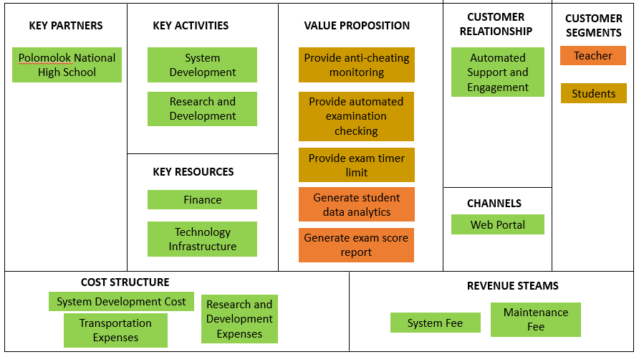

*Figure 3.2 PNHS WBEPMS Business Model Canvas*

*This is the strategic management and lean startup template for the development of the PNHS WBEPMS: Web-based Examination and Performance Management System. This is the overview that lays out both what the system is for and how it will run.*

## Gantt Chart

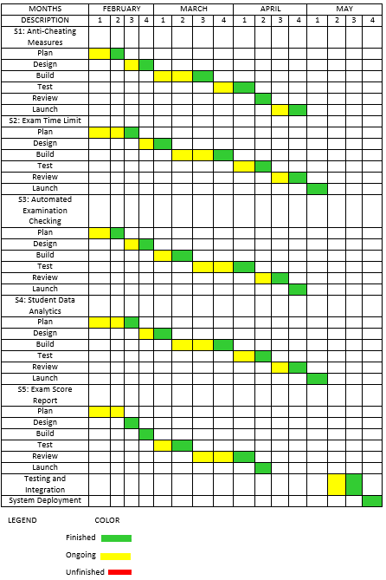

*Figure 3.3: Gantt Chart*

*This chart illustrates this project’s schedule. This illustrates the start and ending week of the terminal elements and summary elements of the project. Terminal elements and summary elements comprise the work breakdown structure of the development of the system.*

## Functional Decomposition Diagram

*Figure 3.4: Functional Decomposition Diagram*

*This figure shows the flow of the PNHS WBEPMS: Web-based Examination and Performance Management System.*

## Use Case Design Phase

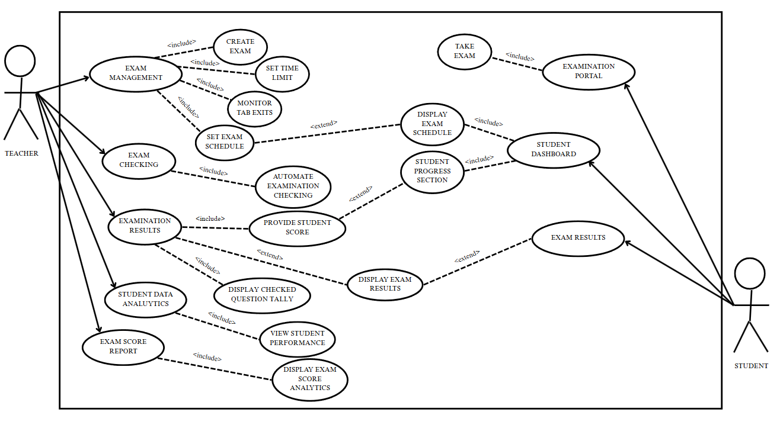

*Figure 3.5: PNHS WBEPMS Use Case Design*

*A use case diagram is a graphical depiction of a user's possible interactions with a system.*

## Use Case Matrix

| **General Characteristics** | |
| --- | --- |
| **Intent** | To identify the purpose of the features that PNHS Web-based Examination and Performance Management System has |
| **Scope** | The scope of this Use Case is Teacher and Student Only |
| **Level** | 2nd Level |
| **Author** | Mercado, Ricky, Ramac, Amir Hedji, Carriedo, Rhea Mae, Mina, Christian Vincent, Felisilda, Arvie Jyro |
| **Last Update** | May 20, 2025 |
| **Status** | Ongoing |
| **Primary Actor** | The teacher, who has access to all managed data |
| **Secondary Actor** | Student can take the examination |
| **Precondition** | The developer must assist the teacher and student in using this system |
| **<Dynamic Precondition>** | The teacher and student must explore the system to familiarize themselves with the functions that run without encountering problems |
| **Assumptions** | All the Dynamic Preconditions are running successfully |
| **Trigger** | When the teacher and student log in and start to add new records and details to the system |
| **Success Post Condition** | After login, all the functions and features that are based on the current problem were running successfully |
| **Failed Post Condition** | Other modules are still in progress |
| **<Model>** | Use Case Matrix |
| **Operation Concepts** | In implementing this system, the system must run according to the features that the developers created in observing the current problems of the respondents. The functions will help in managing the PNHS Web-based Examination and Performance Management System in Examination operations. |
| **Overview** | Several Modules are not fully functional and are still in progress. Analyzing and correcting the errors will ensure smooth use before full implementation. |

*Table 3.1: PNHS WBEPMS Use Case Matrix*

## Storyboard

**Forms**

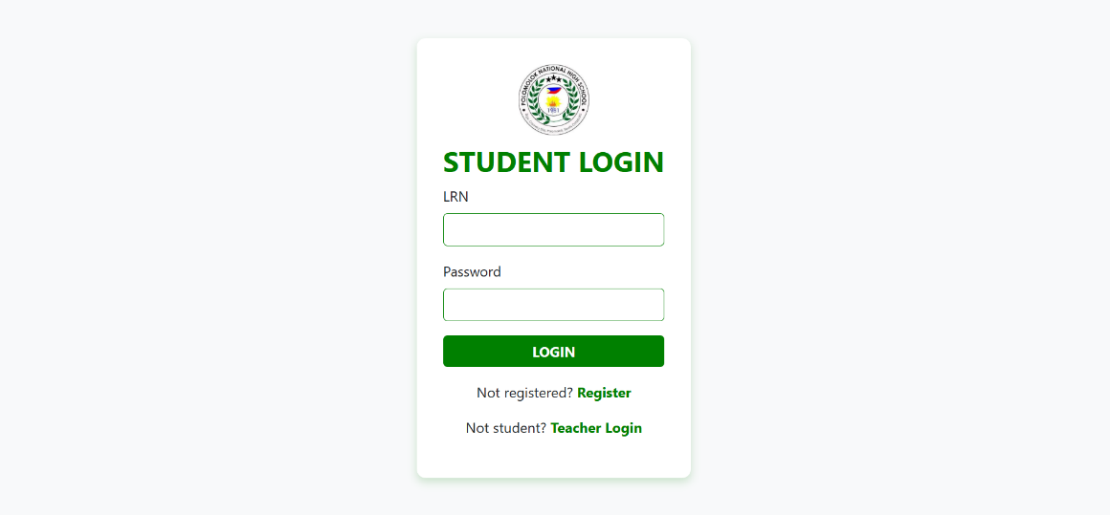**Login Page**

*Figure 3.7.1: This is the Login Page where the user inputs their login details.*

**Students Page**

**Dashboard Page**

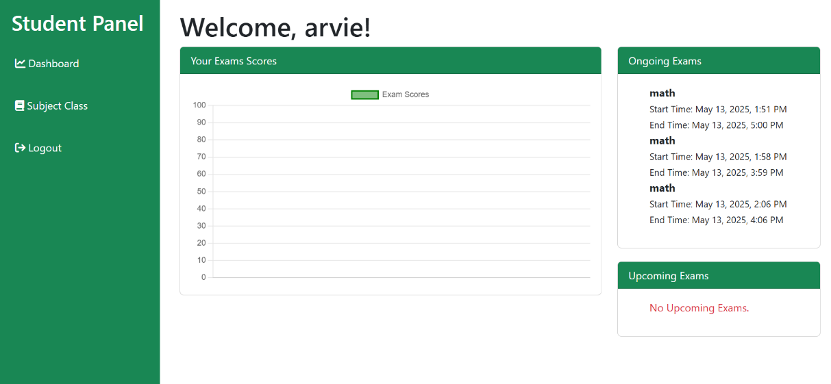

*Figure 3.7.2: This is the Dashboard Page of the students.*

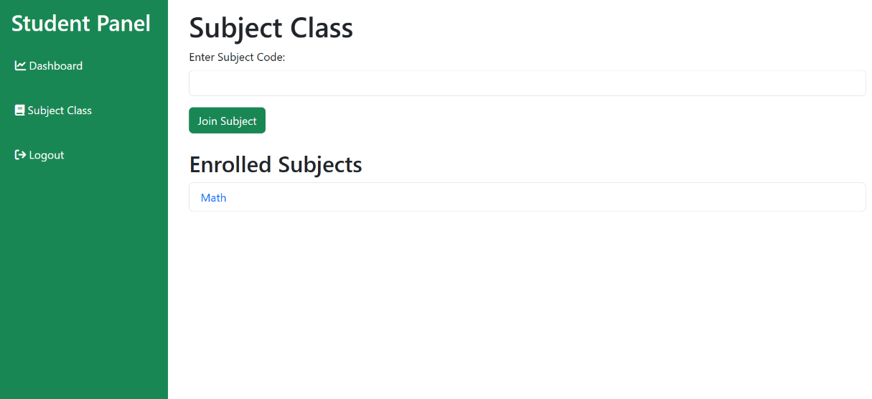**Access Class Code Page**

*Figure 3.7.3: This is the Enter the Class code Page of the Students and view subjects.*

**View Exams Page**

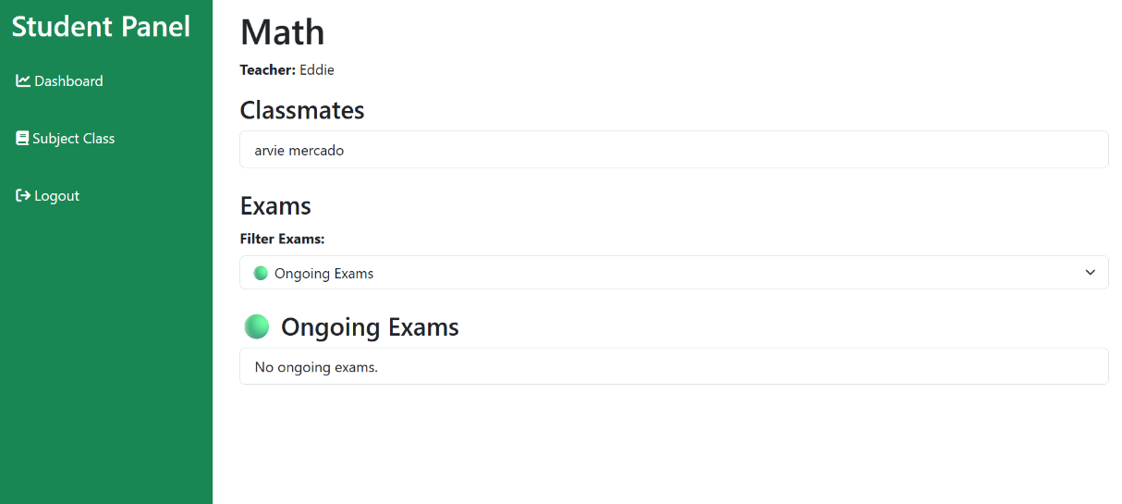

*Figure 3.7.4: This is the View Exams Page where the Students can view Ongoing exams, Upcoming exams and Finished Exams.*

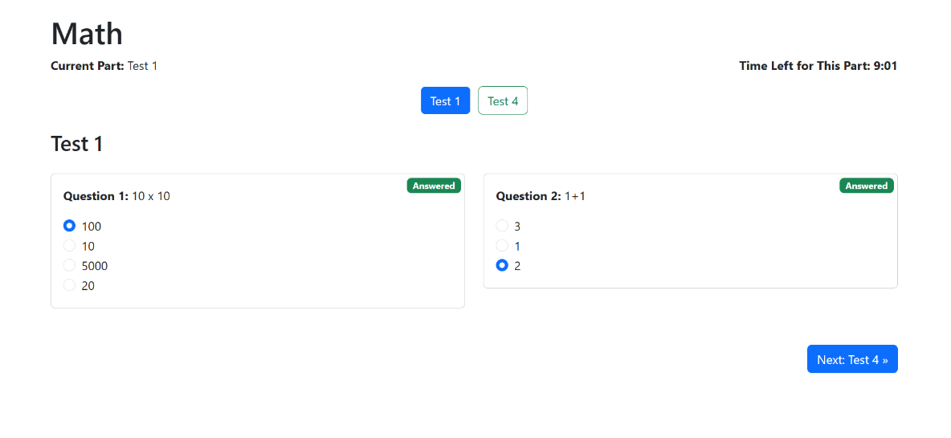**Taking Exams Page**

*Figure 3.7.5: This is the Taking Exams Page where the students Answering the Exams.*

**Teachers Page**

**Dashboard Page**

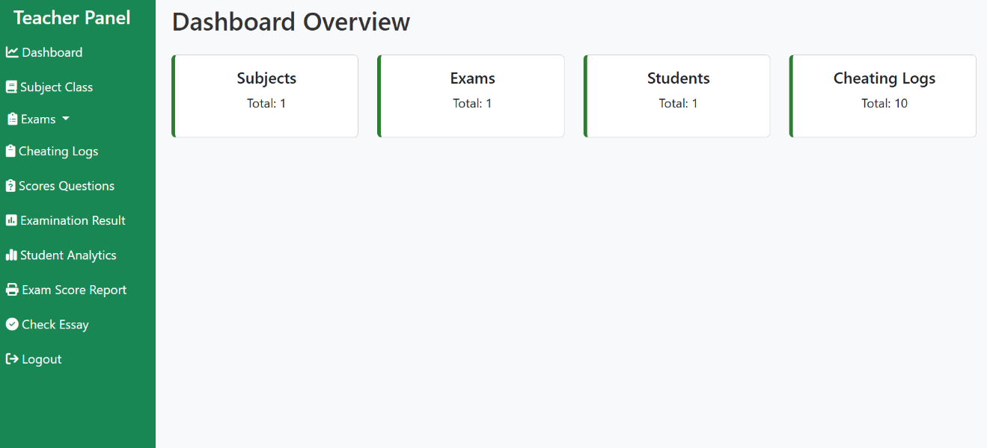

*Figure 3.7.6:This is the Dashboard Page of the Teachers.*

**Creating Subjects Page**

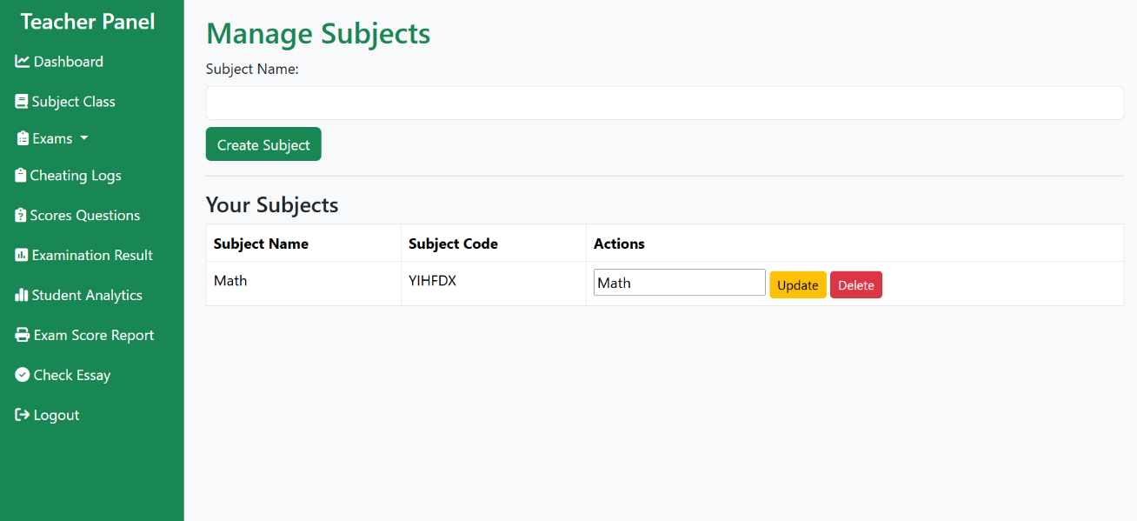

*Figure 3.7.7: This is the Creating Subjects Page that can generate subject code to enter the students to the class.*

**Creating Exams Page**

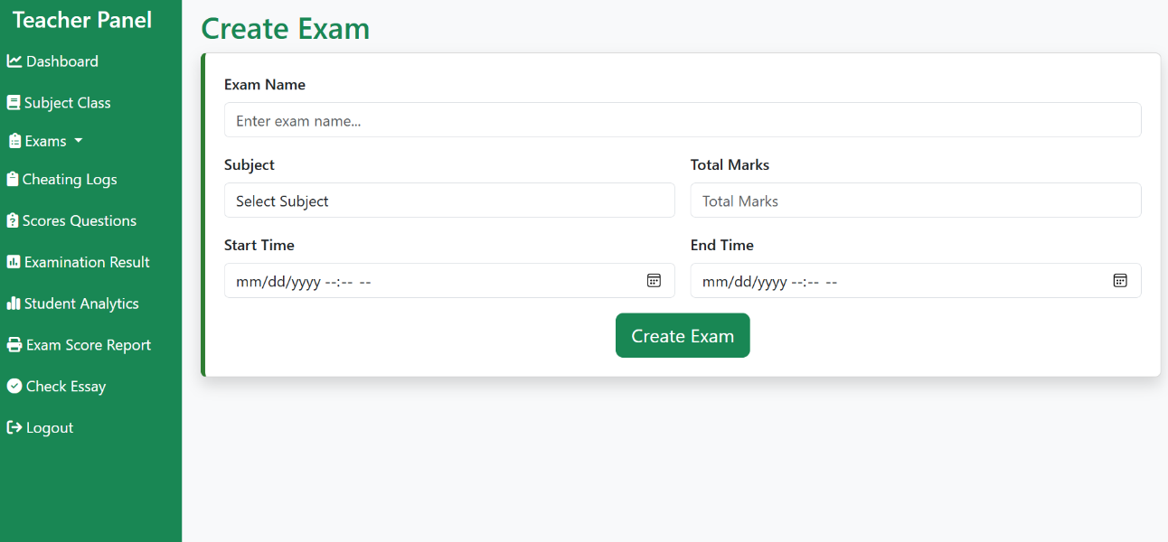

*Figure 3.7.8: This is the Creating Exams Page Teachers can implement a questions and set timer and dates.*

**Manage or Editing Exams Page**

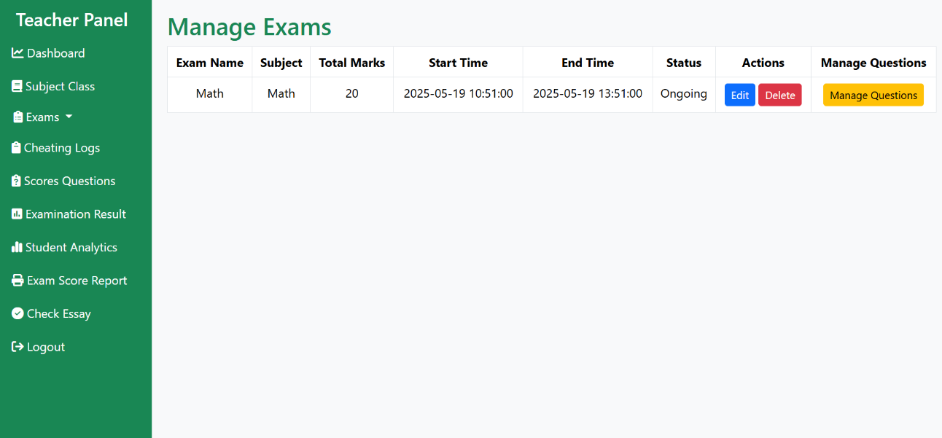

*Figure 3.7.9: This is the Manage or Editing Exams Page Teachers can Edit the questioners and time.*

**Cheating Logs Page**

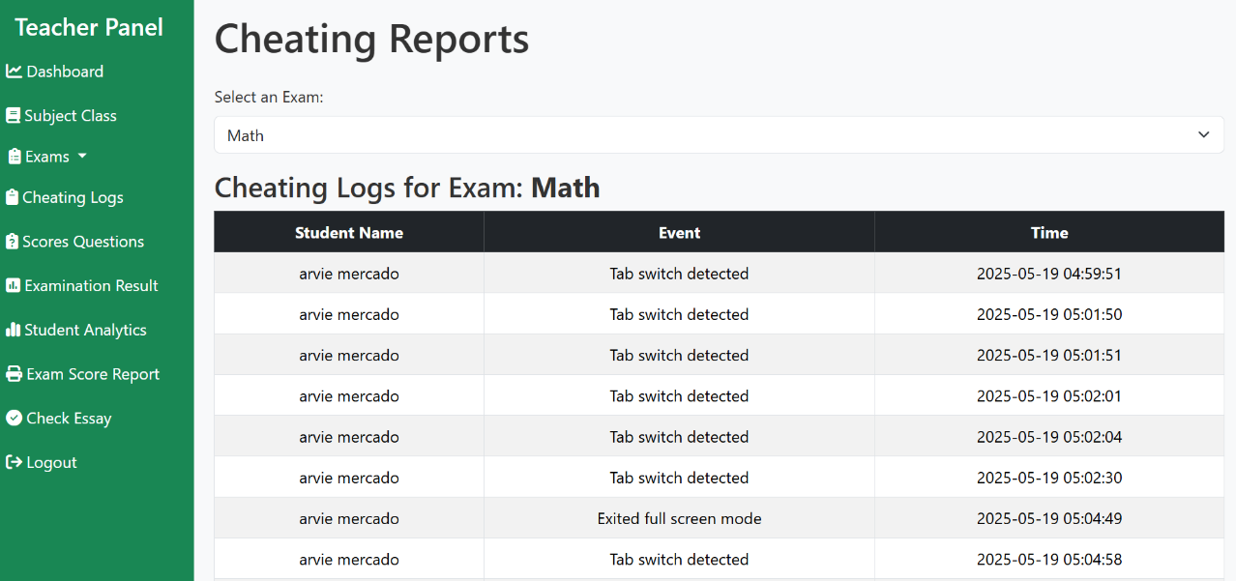

*Figure 3.8.0: This is the Cheating Logs Page Teachers can view the tab switching and can see names of the students and time.*

**Student Analytics Page**

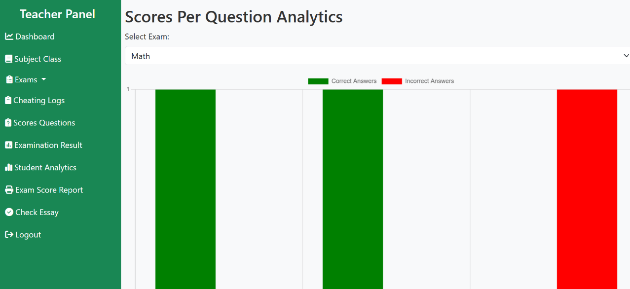

*Figure 3.8.1: This is the Student Analytics Page Teachers can see the right and wrong answers to a questions.*

**Examination Results Page**

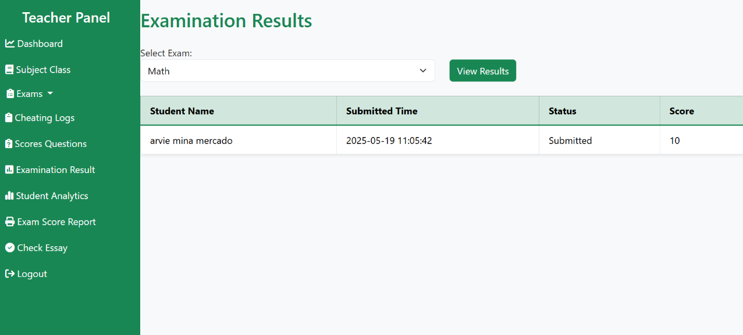

*Figure 3.8.2: This is the Examination Results Page Teachers can view who submitted the exams and scores.*

**Exam Scores Report Page**

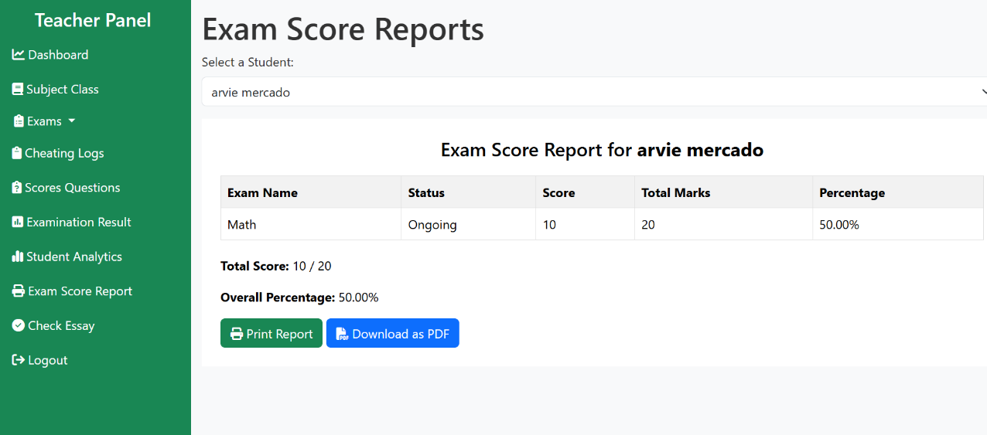

**Exam Scores Report Print**

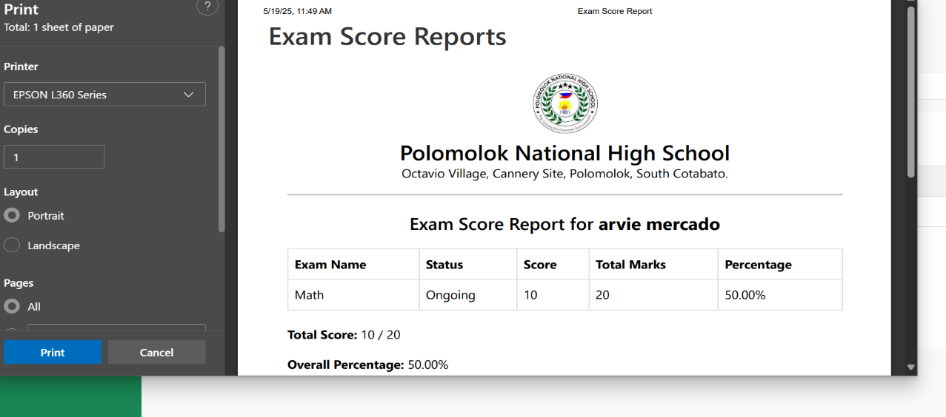

**Exam Scores Report PDF file**

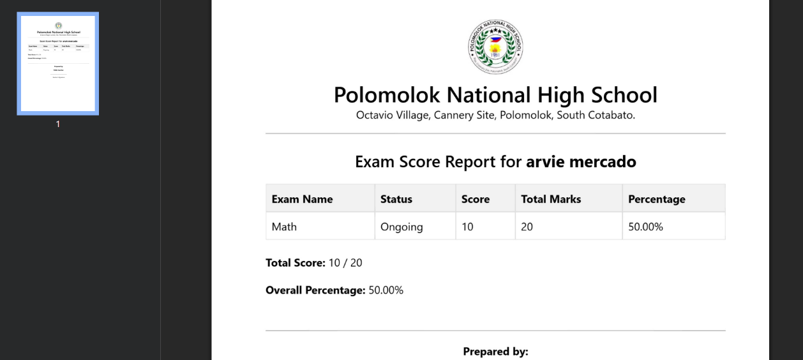

*Figure 3.8.3: This is the Exam Score Reports Page Teachers can print and download a pdf a file of the reports of a students.*

**Check Essay Page**

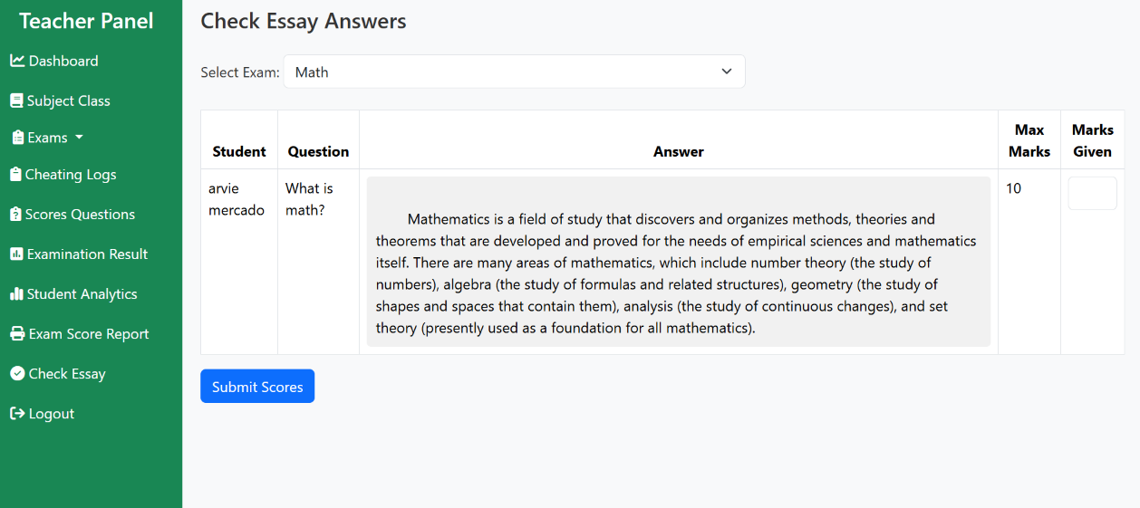

*Figure 3.8.4: This is the Check Essay Page Teachers can checking the essays and marks a score of the students.*

## Database Design

*Figure 3.9: PNHS WBEPMS Database design.*

*This figure will determine what data is stored and managed.*

## Entity Relationship Diagram

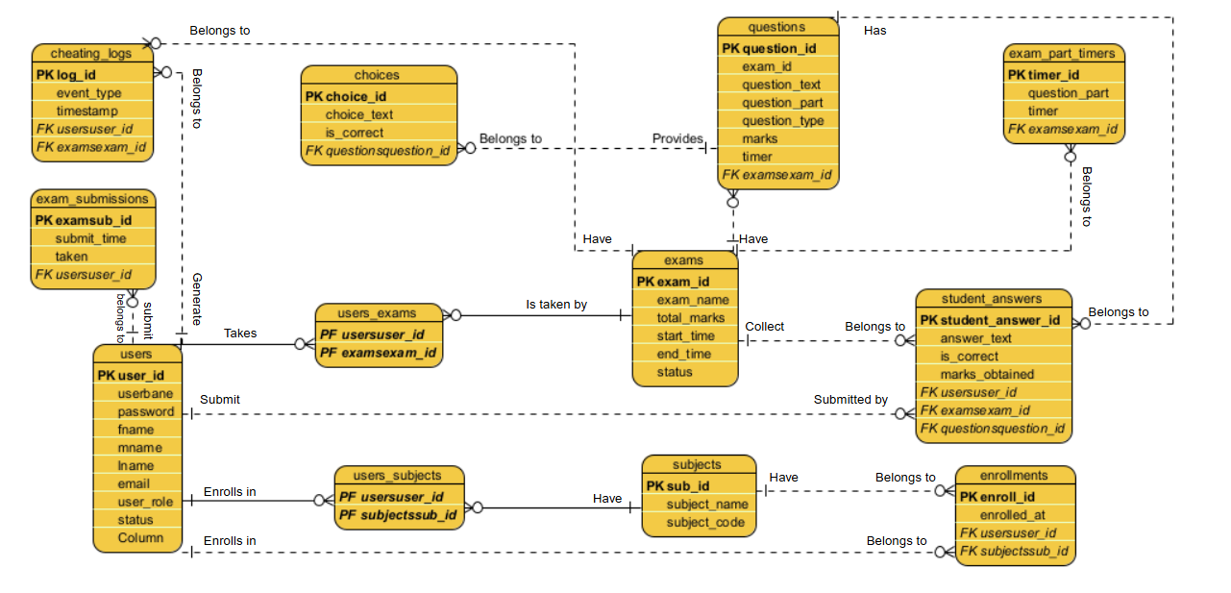

*Figure 3.10: Entity Relationship Diagram to depict relationships among the users, objects, or events within the PNHS WBEPMS.*

## Data Dictionary

|  |  |  |  |  |
| --- | --- | --- | --- | --- |
| **Table Name: users** | |  | | |
| **Description: This table is where it stored the credentials of the users** | | | | |
| **Attribute** | **Data Type** | **Null** | **Default Value** | **Description** |
| User_id | int(11) | No | PK | The ID of the users |
| Username | varchar(55) | No |  | User’s username |
| Password | varchar(255) | No |  | User’s password |
| Fname | varchar(55) | No |  | User’s first name |
| Mname | varchar(55) | No |  | User’s middle name |
| Lname | varchar(55) | No |  | User’s last name |
| Email | Varchar(55) | No |  | User’s Email |
| User_role | varchar(55) | No |  | Type of the user being login to the system |

*Table 3.2.1: Data Dictionary users Table of PNHS WBEPMS.*

|  |  |  |  |  |
| --- | --- | --- | --- | --- |
| **Table Name: subjects** | |  | | |
| **Attribute** | **Type** | **Null** | **Default** | **Description** |
| Sub_id | int(11) | No | PK | The ID of the subjects |
| Subject_name | varchar(55) | No |  | Name of the subject |
| Teacher_id | int(11) | No |  | ID of the teacher |
| Subject_code | varchar(55) | No |  | Code of the Subject |

*Table 3.2.2: Data Dictionary subjects Table of PNHS WBEPMS.*

|  |  |  |  |  |
| --- | --- | --- | --- | --- |
| **Table Name: enrollments** | |  | | |
| **Attribute** | **Type** | **Null** | **Default** | **Description** |
| Enroll_id | int(11) | No | PK | Enroll ID |
| Student_id | int(11) | No | FK | Student id |
| Sub_id | int(11) | No |  | Subject ID |
| Enroll_at | timestamp | No |  | When student’s enroll |

*Table 3.2.3: Data Dictionary enrollments Table of PNHS WBEPMS.*

|  |  |  |  |  |
| --- | --- | --- | --- | --- |
| **Table Name: exams** | |  | | |
| **Attribute** | **Type** | **Null** | **Default** | **Description** |
| Exam_id | int(11) | No | PK | Exam id |
| Exam_name | varchar(50) | No |  | Exam’s name |
| Sub_id | int(11) | No |  | Subjects ID |
| Teacher_id | int(11) | No |  | Teacher’s ID |
| Total_marks | int(11) | No |  | Total Score of the exams |
| Start_time | datetime | No |  | Start time of the exam |
| End_time | datetime | No |  | End time of the exam |

*Table 3.2.4: Data Dictionary exams Table of PNHS WBEPMS.*

|  |  |  |  |  |
| --- | --- | --- | --- | --- |
| **Table Name: questions** | |  | | |
| **Attribute** | **Type** | **Null** | **Default** | **Description** |
| Question_id | int(11) | No | PK | ID of the question |
| Exam_id | int(11) | No |  | ID of the Exam |
| Question_text | text | No |  | Question of the exam |
| Question_type | varchar(55) | No |  | Type of question |
| Marks | int(11) | No |  | Marks per question |

*Table 3.2.5: Data Dictionary questions Table of PNHS WBEPMS.*

|  |  |  |  |  |
| --- | --- | --- | --- | --- |
| **Table Name: choices** | |  | | |
| **Attribute** | **Type** | **Null** | **Default** | **Description** |
| Choce_id | int(11) | No | PK | ID of the choices |
| Question_id | int(11) | No |  | ID of the question |
| Choice_text | text | No |  | Choices per question |
| Is_correct | tinyint(4) | No |  | Choices correct Answer |

*Table 3.2.6: Data Dictionary choices Table of PNHS WBEPMS.*

|  |  |  |  |  |
| --- | --- | --- | --- | --- |
| **TableName: exam_part_timer** | |  | | |
| **Attribute** | **Type** | **Null** | **Default** | **Description** |
| Exam_part_id | int(11) | No | PK | ID of the exam part |
| Exam_id | int(11) | No |  | ID of the Exam |
| Question_part | varchar(10) | No |  | Exam question part |
| Timer | tinyint(4) | No |  | Timer per exam part |

*Table 3.2.6: Data Dictionary exam_part_timer Table of PNHS WBEPMS.*

|  |  |  |  |  |
| --- | --- | --- | --- | --- |
| **TableName: student_answer** | |  | | |
| **Attribute** | **Type** | **Null** | **Default** | **Description** |
| Student_answer_id | int(11) | No | PK | ID of the student’s answer |
| Student_id | int(11) | No |  | ID of the student |
| Exam_id | int(11) | No |  | ID of the Exam |
| Question_id | int(11) | No |  | ID of the question |
| Answer_text | text | No |  | Answer of the student |
| Is_correct | tinyint(1) | No |  | Correct or Incorrect answer |
| Marks_obtained | int(11) | No |  | Marks Obtained correct answer |

*Table 3.2.6: Data Dictionary student_answer Table of PNHS WBEPMS.*

|  |  |  |  |  |
| --- | --- | --- | --- | --- |
| **TableName: exam_submissions** | |  | | |
| **Attribute** | **Type** | **Null** | **Default** | **Description** |
| Examsub_id | int(11) | No | PK | ID of the Exam Submission |
| Student_id | int(11) | No |  | ID of the student |
| Exam_id | int(11) | No |  | ID of the Exam |
| Submit_time | datetime | No |  | Time student submit exam |
| Taken | tinyint(1) | No |  | Student Submitted or not |

*Table 3.2.6: Data Dictionary exam_submissions Table of PNHS WBEPMS.*

|  |  |  |  |  |
| --- | --- | --- | --- | --- |
| **TableName: cheating_logs** | |  | | |
| **Attribute** | **Type** | **Null** | **Default** | **Description** |
| log_id | int(11) | No | PK | ID of the Log |
| Student_id | int(11) | No |  | ID of the student |
| Exam_id | int(11) | No |  | ID of the Exam |
| Event_type | varchar(55) | No |  | Activity Description Record |
| Timestamp | timestamp | No |  | Time of the activity log |

*Table 3.2.6: Data Dictionary cheating_logs Table of PNHS WBEPMS.*

## Network Design

Network design is the integration of the connection type of the devices to achieve end-to-end communication between the devices in the network, which helps to identify the type of topology the PNHS Web-based Examination and Performance Management System is going to use.

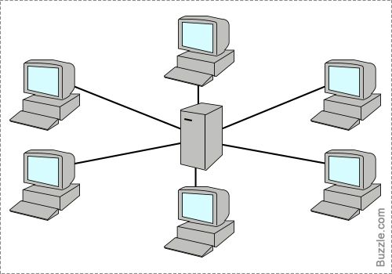

*Figure 3.11: PNHS Web-based Examination and Performance Management System Network Design*

## Network Topology

The Network model that will be used is the Star Topology model. In this model, every node connects to the central network device, such as a hub, switch, or master computer. The central device manages the transmission of data and communication in every node. The system is designed to operate within the private local network. All system functions and data storage are stored and organized in the master computer.



*Figure 3.12: PNHS Web-based Examination and Performance Management System Network Topology*

## Development/Construction/Build Phase

### Technological Stack

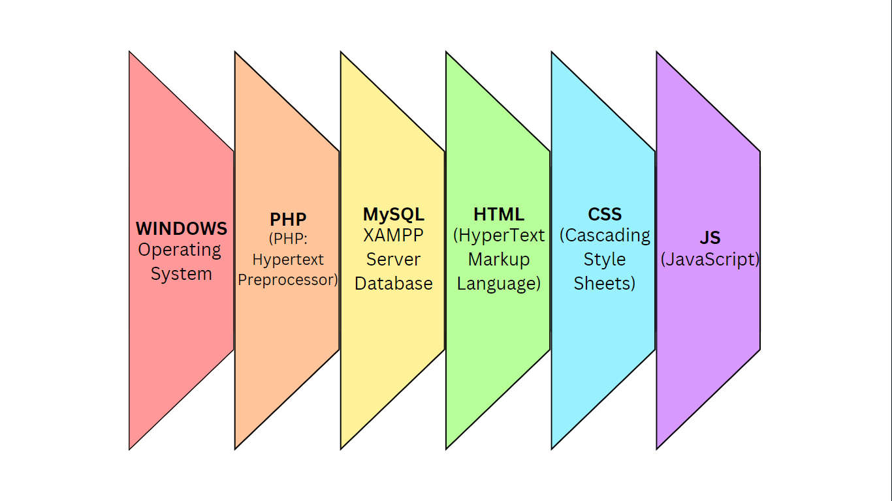

*Figure 3.13: SEAIT School Clinic Management System Technology Stack*

## Software Specification

Language: PHP

Technology: HTML, CSS Framework, JS, PHP

Database: MySQL XAMPP Server

IDE: Visual Studio Code

Operating System: Microsoft Windows 10

## Hardware Specification

Processor: Intel Core i3 6th gen

Hard Disk: 464 GB

RAM: 8.00 GB

## Program Specification

Language: PHP

Database: MySQL

IDE: Visual Studio Code

## List of Modules

**Exam Creation Module**

This module can create exam, schedule exam, exam questions, choices, and exam timer per exam parts.

**Examination Module**

This module can take examination for the students and record exam submissions.

**Student Data Analytics Module**

This module shows the student performance per exam and the correct and incorrect answers.

**Exam Report Module**

This module shows all exam score of the students and suggestion for more improvements.

# CHAPTER IV

# RESULTS AND DISCUSSION

This section presents the results of the system usability evaluation.

**Development and Testing**

The development of a Web-based Examination and Performance Management System was focused on addressing the assessment needs of Polomolok National High School by enhancing the examination integrity, automating the checking process, and tracking student performance. Key features include anti-cheating measures such as monitoring tab exits and randomized questions, automating checking exams, exam time limit, student data analytics, and exam score reports. These functionalities aim to simplify the examination process to improve accuracy in checking examinations and provide data reports to teachers for clearer insights.

The system was tested to ensure it met the functional and performance objectives set during the proposal phase. Testing focused on verifying usability, feasibility, reliability, and effectiveness of the 5 key features. A 5-point Likert scale evaluation tool, part of the System Usability Scale (SUS), was employed during testing. The testing involved 20 participants from Polomolok National High School with a processing examination. The participants included ten teachers and ten students.

**System Usability Scale**

**Figure 1.**

***System Usability Scale Evaluation Form***

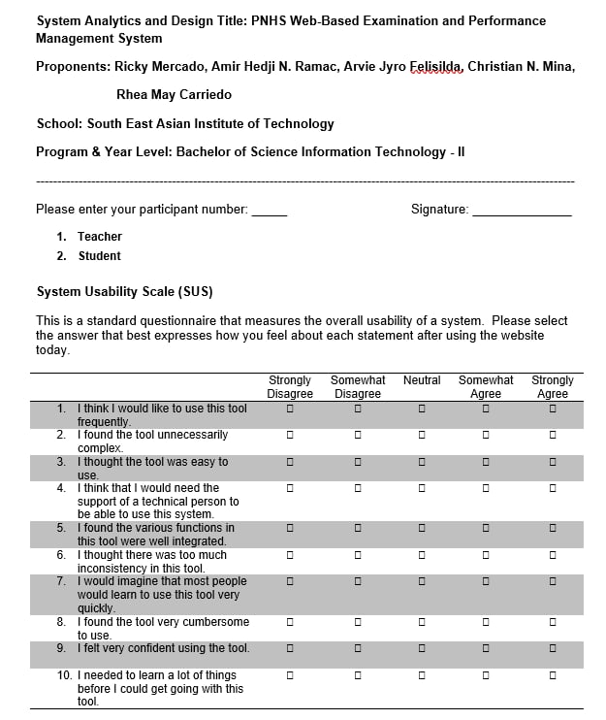

Figure 11 shows the System Usability Scale (SUS) Evaluation Form used to assess the system's usability and functionality. This form consists of a 10-item questionnaire designed to capture user feedback on their experience with the system, using a 5-point Likert scale ranging from "Strongly Disagree" to "Strongly Agree."

**Evaluation Result**

The Web-based Examination and Performance Management System was evaluated by two participant groups: Teacher and Student. The System Usability Scale (SUS) tool assessed the system's usability, effectiveness, and efficiency. The respondents' scores were ranked from 1 to 5 based on how much they agreed with the statements. A score of 5 indicates they strongly agree, a score of 4 means they somewhat agree, a score of 3 means neutral, a score of 2 means somewhat disagree, and a score of 1 means strongly disagree. Odd-numbered questions were summed and subtracted by 5 to determine the usability score, while even-numbered questions were subtracted by 25. The final results were multiplied by 2.5 to yield the total SUS score.

The final SUS scores for the participants were as follows: Teachers received an average score of 75.5, and Students averaged 76.75. These results indicate that the Web-based Examination and Performance Management System is an effective system, well-received by students who rated it highly for usability and functionality. However, Teachers, while generally positive, indicated that more familiarity with the system would enhance their experience as they were still adjusting to its interface and processes.

The overall mean SUS score across all participants reflects that Web-based Examination and Performance Management System is an acceptable system with high usability. With an average of 76.12, the system is a valuable tool for the Polomolok National High School, supporting improved examination and simplifying the examination process.

Aside from the positive usability scores, the system’s features performed seamlessly across all examination processes, including checking, time limit, anti-cheating, and generating reports. All modules functioned effectively as designed, ensuring that every operation related to examination was handled efficiently.

**Table 1.**

***Raw Results of Respondent Responses***

|  |  |  |  |  |  |  |
| --- | --- | --- | --- | --- | --- | --- |
| **Respondent No.** | **R1** | **R2** | **R3** | **R4** | **R5** | **R6** |
| **Question** | **Respondents** | | | | | |
| **T1** | **T2** | **T3** | **T4** | **T5** | **T6** |
| **1** | **3** | **4** | **3** | **5** | **3** | **3** |
| **2** | **3** | **3** | **4** | **2** | **1** | **3** |
| **3** | **3** | **4** | **4** | **5** | **3** | **2** |
| **4** | **3** | **3** | **3** | **1** | **1** | **2** |
| **5** | **3** | **5** | **5** | **5** | **5** | **5** |
| **6** | **1** | **3** | **2** | **1** | **4** | **2** |
| **7** | **4** | **5** | **4** | **4** | **5** | **5** |
| **8** | **1** | **2** | **2** | **1** | **2** | **1** |
| **9** | **3** | **3** | **4** | **5** | **4** | **3** |
| **10** | **2** | **3** | **1** | **1** | **2** | **4** |

**Were,**

**T** – Teacher (10)

**S** – Student (10)

|  |  |  |  |  |  |  |
| --- | --- | --- | --- | --- | --- | --- |
| **Respondent**  **No.** | **R7** | **R8** | **R9** | **R10** | **R11** | **R12** |
| **Question** | **Respondents** | | | | | |
| **T7** | **T8** | **T9** | **T10** | **S1** | **S2** |
| **1** | **3** | **5** | **4** | **3** | **4** | **5** |
| **2** | **2** | **2** | **2** | **3** | **3** | **4** |
| **3** | **3** | **4** | **5** | **4** | **4** | **3** |
| **4** | **1** | **4** | **4** | **2** | **2** | **1** |
| **5** | **5** | **5** | **4** | **5** | **5** | **5** |
| **6** | **1** | **1** | **2** | **1** | **1** | **2** |
| **7** | **5** | **5** | **4** | **4** | **3** | **5** |
| **8** | **1** | **2** | **1** | **1** | **2** | **1** |
| **9** | **5** | **5** | **3** | **2** | **4** | **4** |
| **10** | **1** | **1** | **1** | **1** | **5** | **4** |

|  |  |  |  |  |  |  |
| --- | --- | --- | --- | --- | --- | --- |
| **Respondent**  **No.** | **R13** | **R14** | **R15** | **R16** | **R17** | **R18** |
| **Question** | **Respondents** | | | | | |
| **S3** | **S4** | **S5** | **S6** | **S7** | **S8** |
| **1** | **5** | **3** | **3** | **4** | **5** | **4** |
| **2** | **3** | **2** | **1** | **2** | **3** | **3** |
| **3** | **4** | **5** | **4** | **5** | **5** | **5** |
| **4** | **5** | **2** | **3** | **1** | **1** | **3** |
| **5** | **5** | **5** | **5** | **5** | **5** | **5** |
| **6** | **1** | **2** | **2** | **1** | **2** | **3** |
| **7** | **5** | **5** | **4** | **5** | **5** | **4** |
| **8** | **2** | **1** | **1** | **1** | **2** | **1** |
| **9** | **2** | **5** | **5** | **5** | **5** | **1** |
| **10** | **3** | **4** | **1** | **2** | **1** | **2** |

|  |  |  |  |
| --- | --- | --- | --- |
| **Respondent**  **No.** | **R19** | **R20** |  |
| **Question** | **Respondents** | | |
| **S9** | **S10** |  |
| **1** | **5** | **5** |
| **2** | **4** | **1** |
| **3** | **4** | **4** |
| **4** | **3** | **4** |
| **5** | **5** | **4** |
| **6** | **2** | **5** |
| **7** | **3** | **5** |
| **8** | **2** | **1** |  |
| **9** | **4** | **5** |  |
| **10** | **1** | **1** |  |

**Table 2.**

***Calculated Respondents Scores***

Table 15 calculates all the odd and even scores, which are all based on the raw scores. SUS equation is: (Calculated Odd Score = ((q1 + q3 + q5 + q7 + q9) – 5)). (Calculated Even Score = (25-(q2 + q4 + q6 + q8 + q10)).

|  |  |  |  |  |  |  |
| --- | --- | --- | --- | --- | --- | --- |
| **QUESTION** | **T1** | **T2** | **T3** | **T4** | **T5** | **T6** |
| **Odd Score** | **11** | **16** | **15** | **19** | **15** | **13** |
| **Even Score** | **15** | **11** | **13** | **19** | **15** | **13** |

|  |  |  |  |  |  |  |
| --- | --- | --- | --- | --- | --- | --- |
| **QUESTION** | **T7** | **T8** | **T9** | **T10** | **S1** | **S2** |
| **Odd Score** | **16** | **19** | **15** | **13** | **15** | **17** |
| **Even Score** | **19** | **15** | **15** | **17** | **12** | **13** |

|  |  |  |  |  |  |  |
| --- | --- | --- | --- | --- | --- | --- |
| **QUESTION** | **S3** | **S4** | **S5** | **S6** | **S7** | **S8** |
| **Odd Score** | **16** | **18** | **16** | **19** | **20** | **14** |
| **Even Score** | **11** | **14** | **17** | **18** | **16** | **13** |

|  |  |  |
| --- | --- | --- |
| **QUESTION** | **S9** | **S10** |
| **Odd Score** | **16** | **18** |
| **Even Score** | **13** | **13** |

**Table 3.**

***System Usability Scale Score***

Table 16 displays the computed SUS score for each respondent. SUS Score equation (SUS Score: (Calculated Odd Score + Calculated Even Score) x 2.5 = SUS Score) (Alana Chinn, 2022).

|  |  |  |  |  |  |
| --- | --- | --- | --- | --- | --- |
| **T1** | **T2** | **T3** | **T4** | **T5** | **T6** |
| SUS Score | SUS Score | SUS Score | SUS Score | SUS Score | SUS Score |
| **75** | **62.5** | **70** | **95** | **75** | **65** |

|  |  |  |  |  |  |
| --- | --- | --- | --- | --- | --- |
| **T7** | **T8** | **T9** | **T10** | **S1** | **S2** |
| SUS Score | SUS Score | SUS Score | SUS Score | SUS Score | SUS Score |
| **87.5** | **85** | **75** | **75** | **67.5** | **75** |

|  |  |  |  |  |  |
| --- | --- | --- | --- | --- | --- |
| **S3** | **S4** | **S5** | **S6** | **S7** | **S8** |
| SUS Score | SUS Score | SUS Score | SUS Score | SUS Score | SUS Score |
| **62.5** | **80** | **82.5** | **92.5** | **90** | **67.5** |

|  |  |
| --- | --- |
| **S9** | **S10** |
| SUS Score | SUS Score |
| **72.5** | **77.5** |

**Table 4.**

**Acceptability Score**

|  |  |
| --- | --- |
| **Respondents** | **SUS Score** |
| T1 | 65 |
| T2 | 62.5 |
| T3 | 70 |
| T4 | 95 |
| T5 | 75 |
| T6 | 65 |
| T7 | 87.5 |
| T8 | 85 |
| T9 | 75 |
| T10 | 75 |
| S1 | 67.5 |
| S2 | 75 |
| S3 | 62.5 |
| S4 | 80 |
| S5  S6  S7  S8  S9  S10 | 82.5  92.5  90  67.5  72.5  77.5 |
| **Average:** | **76.12** |

Table 17 shows the overall mean SUS score across all participants, reflecting that PNHS is an acceptable system with high usability. With a “Good” average of 76.12, the system is a valuable tool for the Polomolok National High School, supporting improved examination processes and performance management.

**Figure 2.**

**Acceptability Score Table**

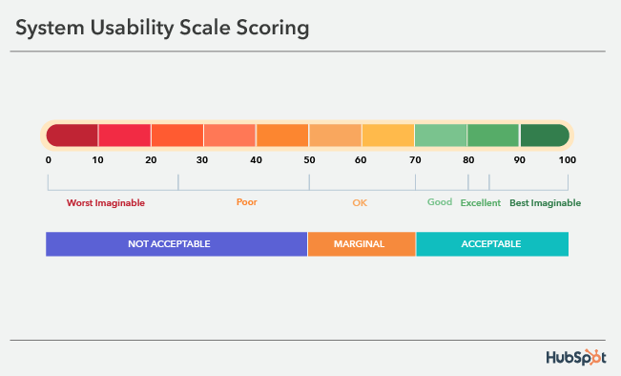

Figure 12 shows the usability assessment of the system based on the System Usability Scale (SUS). According to (Digital.gov, 2024), A SUS score above 68 is considered average, while scores below this threshold are deemed marginal or unacceptable. Scores between 51 and 70 fall into the marginal category, and scores below 50 are considered "Not Acceptable." Conversely, scores above 71 are regarded as "Acceptable," indicating a satisfactory user experience. This scoring system allows grouping respondents' feedback to assess the percentage of high or low usability perceptions, ensuring the system's design meets user expectations and achieves an acceptable usability standard.

**Definition of the Prototype**

The developed prototype is a Web-based Examination and Performance Management System designed to simplify the checking of exams, exam creation, student record scores, and performance tracking for Polomolok National High School. It features core functionalities such as Anti-cheating measures like tab-monitoring exits and randomized questions, Automated Checking Examination, Exam time limit, Student Data Analytics for clearer insights, and Exam Score Reports for the overall calculated score. An integrated student data analytics, including the exam score per quarter, strengths and weaknesses, and scores per exam.

## Conclusions

PNHS Web-based Examination and Performance Management System for Polomolok National High School. received an overall mean SUS score of 76.12 across all participant groups, reflecting its acceptability as a system with high usability. The system has proven to be a valuable tool for supporting improved examination and simplifying the examination processes effectively.

All features of the system were tested and confirmed to be fully functional, working seamlessly across the examination process, including student taking the exam, exam creation, automated checking, student data analytics, and exam score report generation. Respondents found the system to be very useful in simplifying the examination process and improving accessibility.

Overall, PNHS Web-based Examination and Performance Management System significantly enhanced the examination process by providing a functional and user-friendly system that effectively met the needs of stakeholders.

## Recommendations

Based on the respondents’ reviewers’ suggestions, it is recommended that PNHS Web-based Examination and Performance Management System be further enhanced by developing a mobile application version. This would allow students and teachers to access the system conveniently through mobile devices. Additionally, implementing the scan of a picture or uploading a file containing topic content for examination, when scanning or uploading automatically creates examination questions, reduces the workload of the teachers.

# References

Charis Ann M. Sancho, & Uriel M. Melendres. (2020). Development of Dynamic Local Area Network (LAN) Based Mock Board Examination System. *Development of Dynamic Local Area Network (LAN) Based Mock Board Examination System*, *1*(2), 1–3.

Julius G. Garcia, & Connie C. Aunario. (2021). *Implementation of Departmental and Periodical Examination Analyzer System*. *1*(2), 1–3.

Wulandari, S. (2022). *WEB-BASED ONLINE EXAM INFORMATION SYSTEM TO IMPROVE THE QUALITY OF LEARNING EVALUATION FOR STUDENTS*. *2*(3). https://doi.org/10.53067/ije3.v2i3

Ramos, Andrew Joseph, (2022). TESTTIME: An Online Examination System. https://repository.upou.edu.ph/items/ae4d99a7-d3cd-4ab5-ac75-d4b886356039

Letigio et al., (2022).Digital Student Examination System of Cebu Normal University - Balamban Campus in the New Normal: Analysis and Implementation. *https://www.researchgate.net/profile/Deofel-Balijon/publication/366292740_Digital_Student_Examination_System_of_Cebu_Normal_University_-_Balamban_Campus_in_the_New_Normal_Analysis_and_Implementation/links/63cfdb126fe15d6a574476b8/Digital-Student-Examination-System-of-Cebu-Normal-University-Balamban-Campus-in-the-New-Normal-Analysis-and-Implementation.pdf*

Bulauitan et al, (2022).OPEES: Online Proctored Entrance Examination System with Degree Program Recommender for Colleges and Universities.*https://ieeexplore.ieee.org/abstract/document/10109595*

Henderson et al, (2020). A systematic review of online examinations: A pedagogical innovation for scalable authentication and integrity. *https://pmc.ncbi.nlm.nih.gov/articles/PMC7508171/*

Diaz et al, (2020). A Web-Based Mechanical Engineering Pre-Board Examination System with Progress Report for JCSF Engineering Review Center.

*https://www.ejournals.ph/article.php?id=19655&fbclid=IwY2xjawJg8VRleHRuA2FlbQIxMAABHtN-elhALzqQv083pVyTmwyRrA4pMdKrHHs3r1FhHxiuLMKfmUjph7unSOUt_aem_E5jppIHfiVJUjQ4CAFEfiQ*

# CURRICULUM VITAE



**RICKY B. MERCADO**

Poblacion, Polomolok, South Cotabato 9504

rickymerdo@gmail.com

+63 909 203 4481

**PERSONAL DATA**

**Civil Status :** Single

**Date of Birth :** February 19, 2006

**Sex :** Male

**Nationality :** Filipino

**Languages Spoken :** Tagalog, English, Bisaya, Hiligaynon

**Religion :** Catholic

**Father :** Juanito M. Mercado

**Mother :** Alice B. Mercado

**EDUCATIONAL BACKGROUND**

**Tertiary :** South East Asian Institute of Technology, Inc.

Bachelor of Science in Information Technology

2023 - present

**Secondary :** Polomolok National High School

2017 - 2022

**Primary :** Eustacio Barcatan Elementary School

2011 - 2016



**Amir Hedji N. Ramac**

Cannery Site, Polomolok, South Cotabato 9504

amiramac10@gmail.com

+63 968 636 1893

**PERSONAL DATA**

**Civil Status :** Single

**Date of Birth :** November 8, 2004

**Sex :** Male

**Nationality :** Filipino

**Languages Spoken :** Tagalog, English, Bisaya

**Religion :** Catholic

**Father :** Edgardo Ramac

**Mother :** Florita Ramac

**EDUCATIONAL BACKGROUND**

**Tertiary :** South East Asian Institute of Technology, Inc.

Bachelor of Science in Information Technology

2023 - present

**Secondary :** Polomolok National High School

2017 - 2023

**Primary :** Dole Cannery Central Elementary School

2012 - 2017



**CHRISTIAN VINCENT N. MINA**

Purok 3 Lower Mabuhay, Brgy. Topland

Koronadal City, South Cotabato 9506

christianmina653@gmail.com

+63 994 157 0490

**PERSONAL DATA**

**Civil Status :** Single

**Date of Birth :** April 3, 2001

**Sex :** Male

**Nationality :** Filipino

**Languages Spoken :** Tagalog, English, Bisaya

**Religion :** Catholic

**Father :** Panchito B. Mina

**Mother :**  Elizabeth N. Mina

**EDUCATIONAL BACKGROUND**

**Tertiary :** South East Asian Institute of Technology, Inc.

Bachelor of Science in Information Technology

2023 - present

**Secondary :** Marbel 7 National High School

2014 - 2023

**Primary :** Marbel 7 Central Elementary School

2009 – 2014



**RHEA MAY B. CARRIEDO**

Purok Balunto, Labangal,General Santos Ciy 9500

carriedorhea5@gmail.com

+63 926 171 2041

**PERSONAL DATA**

**Civil Status :** Single

**Date of Birth :** July 25, 2005

**Sex :** Female

**Nationality :** Filipino

**Languages Spoken :** Tagalog, English, Bisaya

**Religion :**  Christian

**Father :** Remar E. Carriedo

**Mother :** Cristine B. Carriedo

**EDUCATIONAL BACKGROUND**

**Tertiary :** South East Asian Institute of Technology, Inc.

Bachelor of Science in Information Technology

2023 - present

**Secondary :** General Santos City National High School

2017 - 2023

**Primary :** Balunto Elementary School

2012 - 2017



**ARVIE JYRO FELISILDA**

Prk. Sagrado Valencia Site Polomolok, South Cotabato 9504

Felesildaa@gmail.com

+63 926 413 9841

**PERSONAL DATA**

**Civil Status :** Single

**Date of Birth :** November 25, 2004

**Sex :** Male

**Nationality :** Filipino

**Languages Spoken :** Tagalog, English, Bisaya

**Religion :**  Catholic

**Father :**

**Mother :** Elvie S. Felisilda

**EDUCATIONAL BACKGROUND**

**Tertiary :** South East Asian Institute of Technology, Inc.

Bachelor of Science in Information Technology

2023 - present

**Secondary :** B.E.S.T. College of Polomolok Inc

2017 - 2022

**Primary :** Eustacio Barcatan Elementary School

2011 - 2017

# APPENDICES

**APPENDIX A**

## (Transmittal Letter)

February 16, 2024

**MS. GERALDINE T. HINALAO**

**Principal**

**Polomolok National High School**

**Octavio Village, Brgy Cannery Site, Polomolok**

**South Cotabato, 9504**

**Subject:** Request for Approval to Conduct System Analysis and Design Project

Dear Ms. Hinalao,

We, the second-year Bachelor of Science in Information Technology students of South East Asian Institute of Technology, Inc., are currently developing a system as part of our IT228: System Analysis and Design course requirement.

In line with this, we would like to seek approval from your company to conduct the System Analysis and Design project entitled “**WEB-BASED EXAMINATION AND PERFORMANCE MANAGEMENT SYSTEM.”**

Furthermore, we would like to ask your permission to allow us to conduct the following:

1. Interview authorized personnel concerned for the information needed for this project.
2. Take pictures to be used in the design of the said system.

Rest assured that all information gathered will be kept confidential and will solely be used for academic purposes. We highly appreciate your support and positive response to this request.

Thank you very much, and God Bless.

Sincerely,

**Ricky B. Mercado**

**Christian Vincent N. Mina**

**Amir Hedji N. Ramac**

**Arvie Jyro Felisilda**

**Rhea May B. Carriedo**

Noted by:

**HERNAN JR. E. TRILLANO, MIT**

Project Adviser

Approved by:

**GERALDINE T. HINALAO**

Principal

**APPENDIX B**

## (Project Proposal)

**Project Proposal**

**Name of Proponents:** Ricky B. Mercado.

Amir Hedji N. Ramac.

Christian Vincent N. Mina.

Arvie Jyro Felisilda

Rhea May Carriedo

1. **Proposed Case Study Title:**

PNHS Web-based Examination and Performance Management System

1. **Area of Investigation**

Polomolok National High School

Ocatavio Village, Cannery Site

Polomolok, South Cotabato 9504

1. **Cited Problems**

* Paper-based exams are prone to cheating such as answer sheet swapping, causing unfair assessment.
* Teachers tend to monitor exam time manually, somehow it exceeds to a time limit.
* Manual checking is time- consuming due to a large number of student and double-checking answers leading delayed score results.
* Teachers rely on manually recorded scores for student performance reports, making it difficult to identify areas of improvement and provide academic reports.
* Manually record reports is time-consuming due to manually collect each exam scores leading to delayed scores report.

1. **Function of the Proposed System**

This system is designed to reduce the time teachers spend on administrative tasks and optimize examination process through simplify examination management and automation of student report generation. The system functions as a comprehensive solution to improve the quality and efficiency of student and teacher examinations.

1. **Features of the Proposed System**

* Anti-Cheating Measures
* Exam Time Limit
* Automated Examination Checking
* Student Data Analytics
* Exam Score Report

1. **Programming Language and Database**
   1. **Front End:** HTML, CSS, JS
   2. **Back End:** PHP, MySQL
2. **Reason for the Choice**

* To implement anti-cheating measures such as random-order questions and tab-monitoring to prevent cheating.
* To prevent exceeding the time limit for each exam, ensuring a fair amount of time each student to answer.
* To improve checking exam accuracy by automating the checking examination for multiple-choice, true or false, and fill-in-the-blanks, to reduce manual workload for teachers.
* To provide data analytics on student performance by generating reports to help teachers identify areas of improvement for each student.
* To provide exam scores for student examinations by generating reports to help teachers organize and calculate each student’s examination score.

1. **Importance of the Study**

This study aims to develop a Web-Based Examination and Performance Management System. The system has the potential to significantly impact the school, teachers, and students, leading to improved efficiency and fairness in the examination process. This system aims to benefit the following:

**PNHS**

The school will eliminate the need for paper-based exams, saving time in distribution and collection, reducing manual work, and lowering cost.

**Teachers**

The teachers can create, schedule, and administer exams online without the hassle of printing and distributing papers.

**Students**

The system allows students to take exams anytime, receive instant feedback, track their progress, and get reminders for pending assessments.

**Researchers**

Can use their skills and knowledge in research. It is an opportunity for the researchers to put into practice what they have learned as Information Technology students.

**Future Researchers**

This system would be a great help for future researchers. The documentation and system will serve as their literature or prior art, and the system can be upgraded based on the new requirements.:

1. **Target Users**

* Teachers
* Students

**APPENDIX C**

## (Questionnaire)



**APPENDIX D**

## (Map of Research Environment)

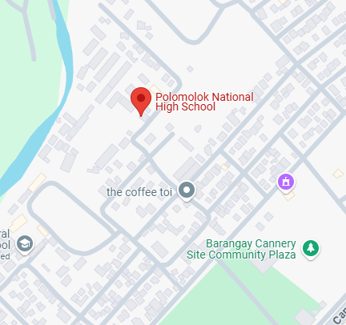

**Polomolok National High School,**

Octavio VIllage, Cannery Site, Polomolok, South Cotabato 9504